|  |  |  |  |  |  |
| --- | --- | --- | --- | --- | --- |
| Date | 1-Dec-22 | | | Tester Name | Shahabuddin Syed |
| Environment | Penfax - Test | | | Login used |  |
| Operating System | Windows | Version: | Update: | | |
| Software Used | Edge | Version: | Update: | | |
| Not Applicable | Version: | Update: | | |
| Release version | 22.4.1 | | | | |
| Title | E21.01b | | | | |
| Test Type | Regression | | | | |
| Test Scenario | Case Management – Create a Member Voluntary Transfer Case | | | | |
|  |  | | | | |
| Expected Results |  | | | | |
| Pass/Fail | Pass | | | JIRA# | N/A |

Describe your steps with screenshots:

Case Management – Dashboard

Click on Add case

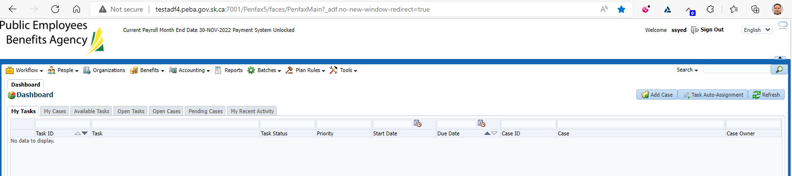

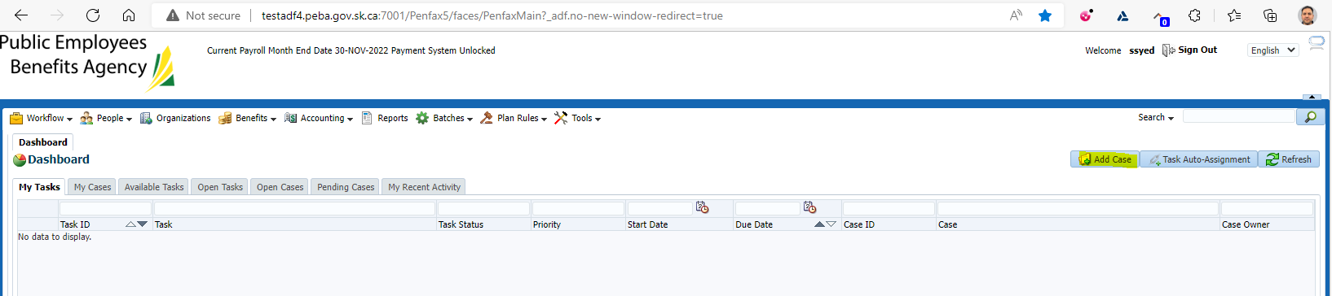

Case Type select as PEPP Contribution Voluntary Transfer In No Service

Select SID- 293931

